USER’S MANUAL
AK32 ,AQ4,AK8
EMBEDDED SYSTEM
VOICE LOGGER



INDEX
pRODUCE overview 1
pRODUCE appearance 2
pRODUCE PC program 4
PC Program introduction 4
Recording file 13
system setting 18
channel parameter 21
voice trigger 24
network setting 24
HDD parameter, system log 24
Recording time section 25
PABX SMDR 26
PABX SMDR configuration 27
other setting 28
online user 28
online account 28
user account management 29
add user account 29
touch screen 31
recording files 31
channel monitor 32
channnel status 32
search 33

EMBEDDED SYSTEM VOICE LOGGER

USER’S MANUAL

The manual includes AK & AQ series. AK & AQ have its own features and appearance. Both of product series use same PC client program,

PRODUCE OVERVIEW
Thanks for purchasing ARTECH AK32 32CH embedded system voice logger.
AK32 is consisted by 667MHz CPU, latest Samsung ARM chip and innovative hardware frame and specific call recording software. Each AK32 voice logger starts from 8 channels and is expandable to 32 channels. AK32 voice logger is a simple stand- alone call recording device with touch screen, speak-phone, and network connection. No PC required, AK32 supports touch screen operation. It achieves playback recording file, instant monitor and search function. AK32, the genuine embedded system voice logger is a perfect recording solution for various industries.

AK Features
- System boots in 20 sec
- Support high capacity SATA HDD 500G/1T/2T
- Expandable from 8 to 16, 24 and 32 channels
- Touch screen operation
- Remote control by network
- Instant playback through speaker
- Removable & hot swappable recording card
- Removable HDD
- Full embedded device, no PC required
- Lower power dissipation supports 7x24x365 running

AQ Features
- System boots in 20 sec
- Support high capacity SATA HDD 500G/1T/2T
- Optional SD card model, max 64GB
- Expandable from 8 to 16, 24 and 32 channels
- Touch screen operation
- Optional model without touch screen (SD/HDD)
- Remote control by network
- Instant playback through speaker
- Full embedded device, no PC required
- Lower power dissipation supports 7x24x365 running

AK HDD Recording Hour
- 500GB : 36,000 Hour
- 1000GB(1T) : 72,000 Hour
- 2000GB(2T) : 144,000 Hour

AQ HDD Recording Hour /SD Recording Hour
- 500GB 36,000 Hour
- 1000GB(1T) 72000 Hour
- 2000GB(2T) 144000 Hour
- 8GB 560 Hour（SD Card）
- 32GB 2240 Hour（SD Card）
- 64GB 4480 Hour（SD Card）

AK Appearance

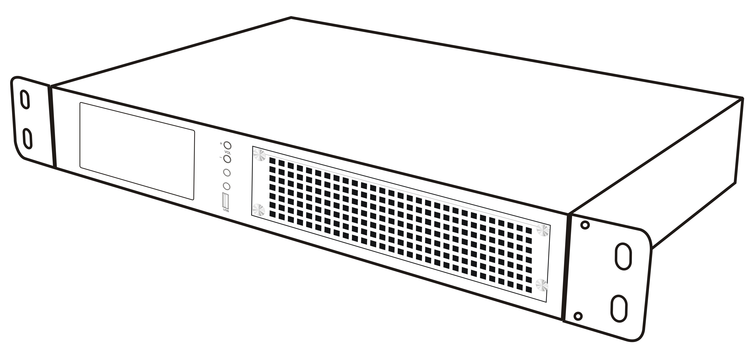

AK Front

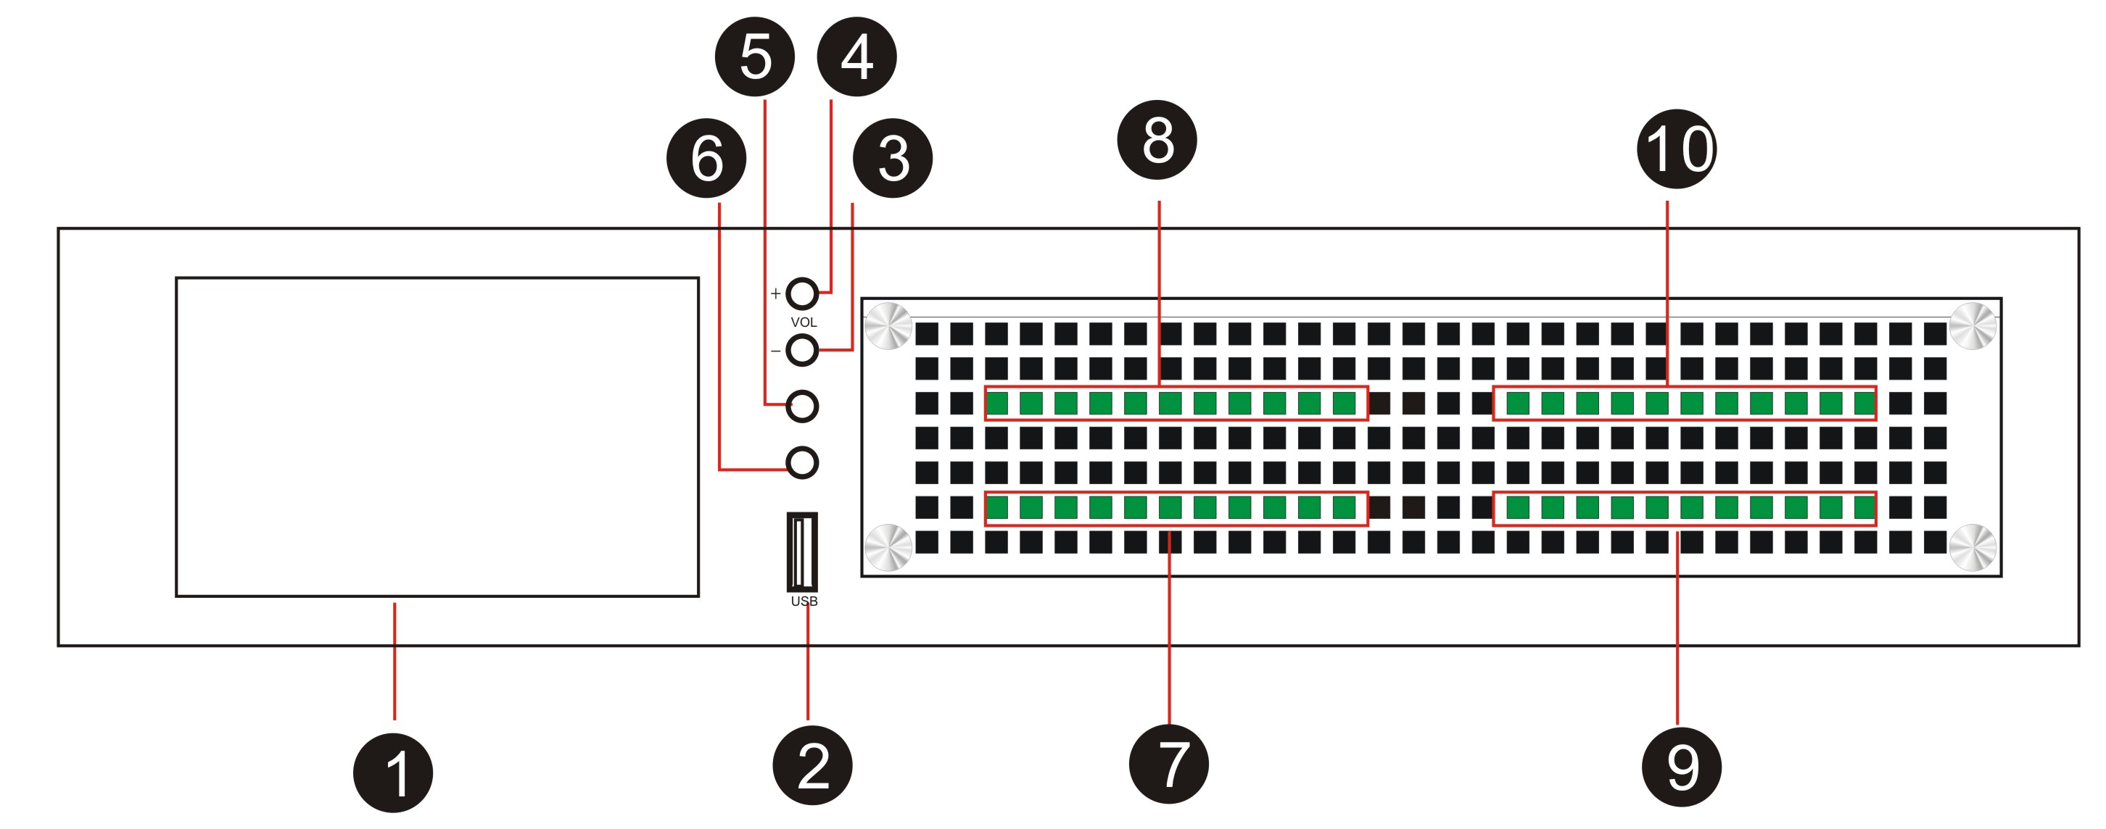

- 5” touch screen, 800 * 480
- USB Host for upgrade or backup HDD
- Volume -
- Volume +
- Earphone (Main)
- Earphone (Sub)
- Card 1 (Channel 01-08)
- Card 2 (Channel 09-16)
- Card 3 (Channel 17-24)
- Card 4 (Channel 25-32)

AK Rear
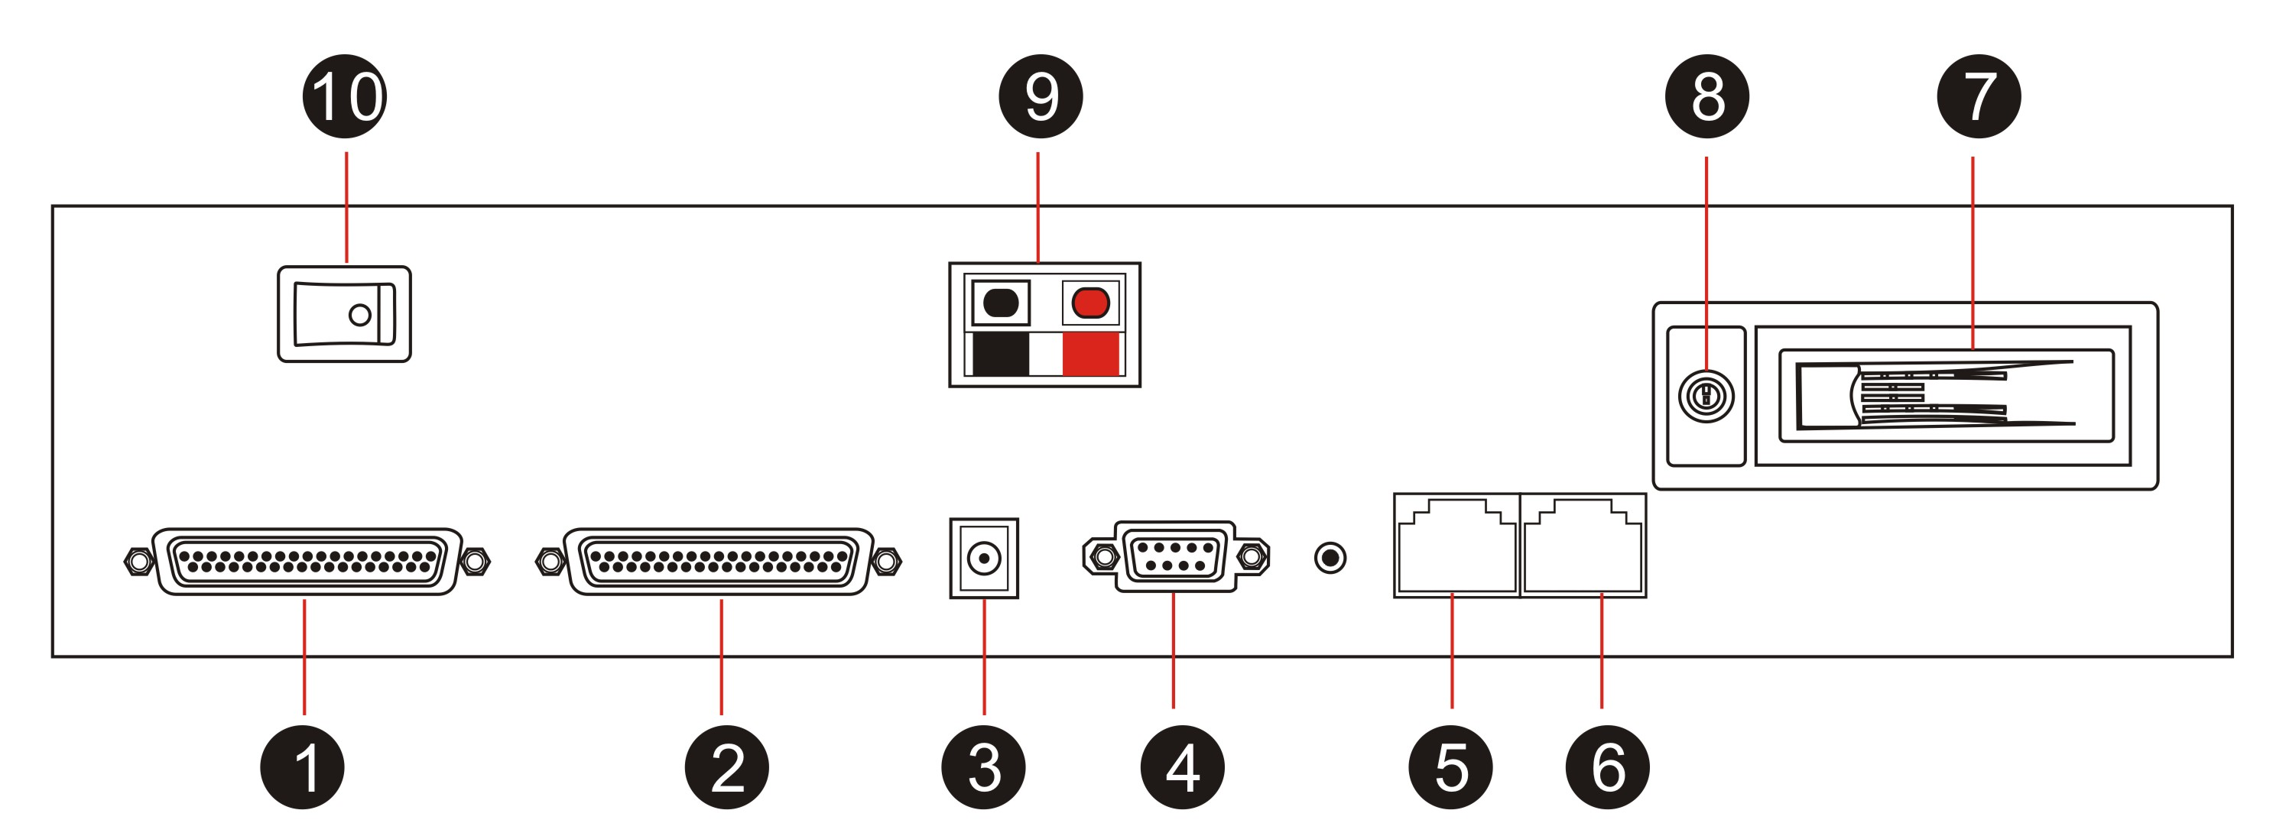

- DB37 for Channel 17-32
- DB37 for Channel 1-16
- Power input : DC-19V
- RS232 for SMDR
- RJ45 for LAN
- RJ45 for WAN (SIP record)
- SATA HDD
- HDD lock
- External power
- Power switch

AQ Appearance
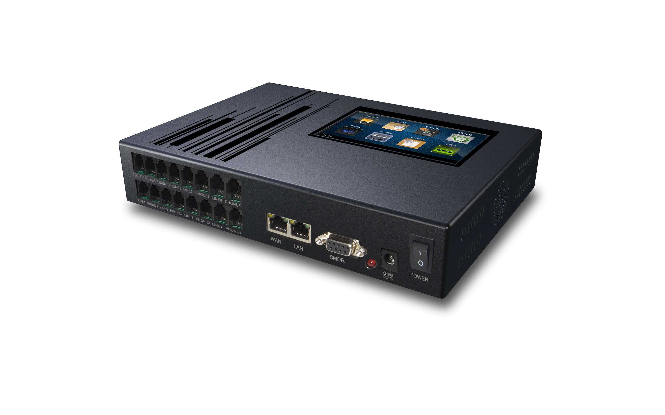

AQ Front
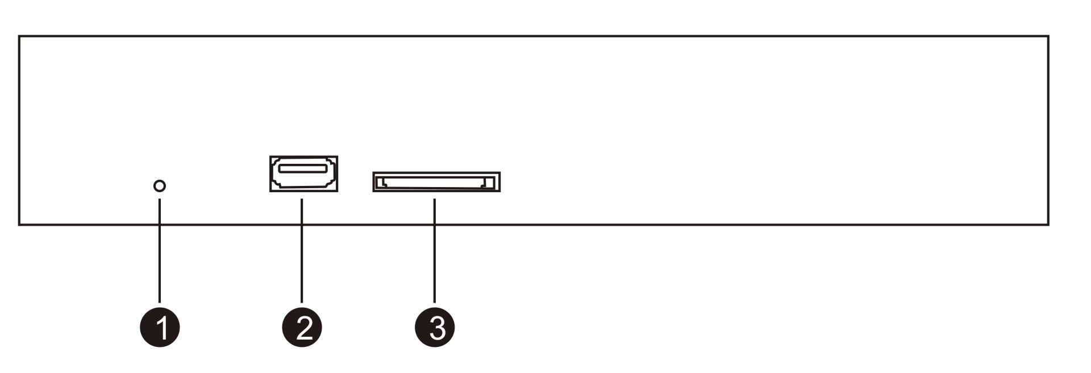
- Power LED
- USB Host for backup or system upgrade
- SD Slot for optional SD card model. No use for HDD model

AQ Rear
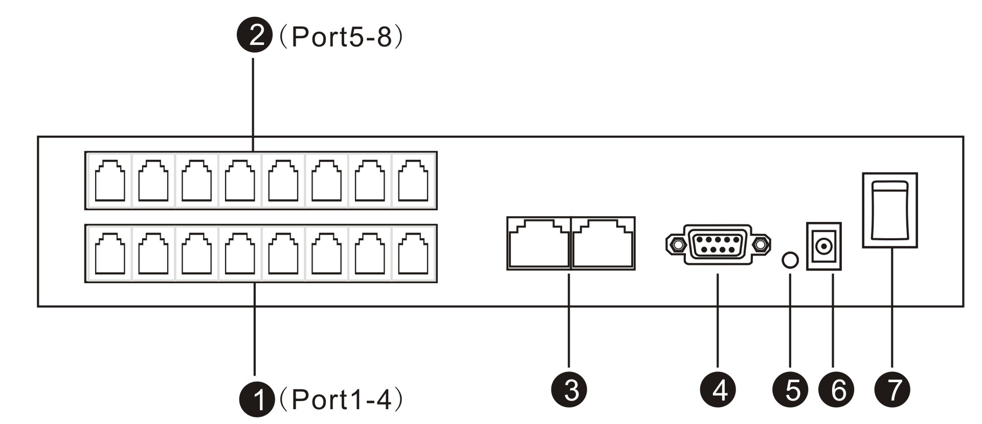

- Card 1, Channel 1-4 (RJ11)
- Card 2, Channel 5-8 (RJ11)
- RJ45 Port x 2
- RS232 Port for SMDR data
- RS232 data indicator
- Power input : DC-19V
- Power switch

AQ Rack (Remove AQ rubber stand first and screw it with rack again)
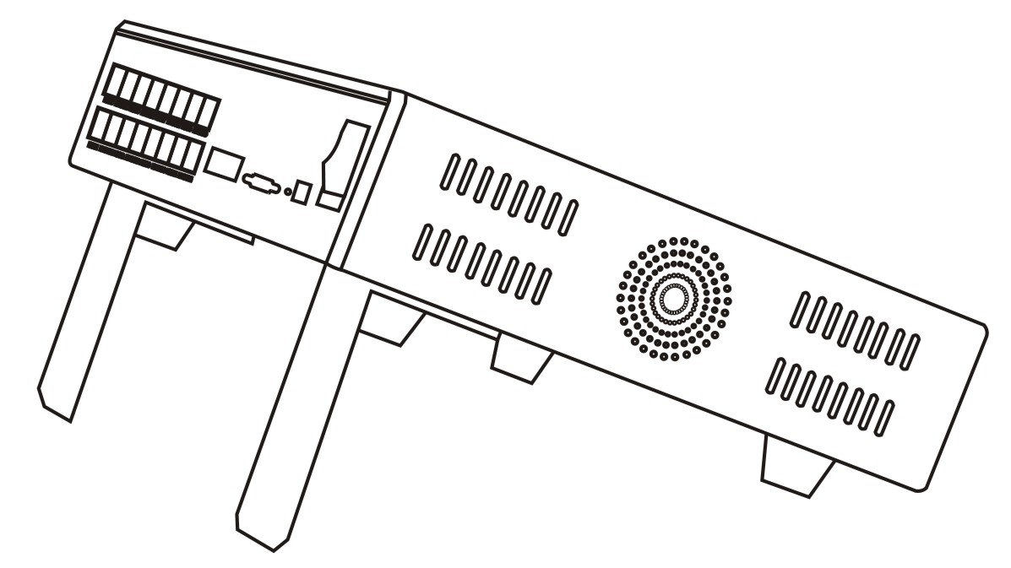
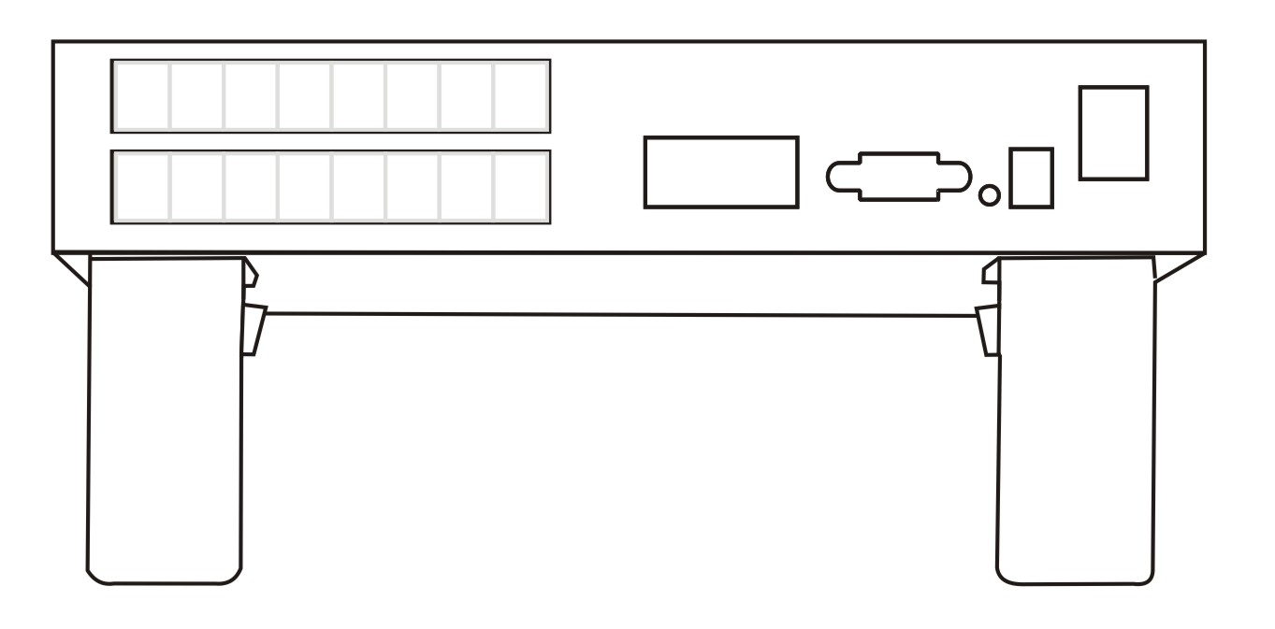


AQ Wall mount (Remove rubber stand and screw it with wall mount again)
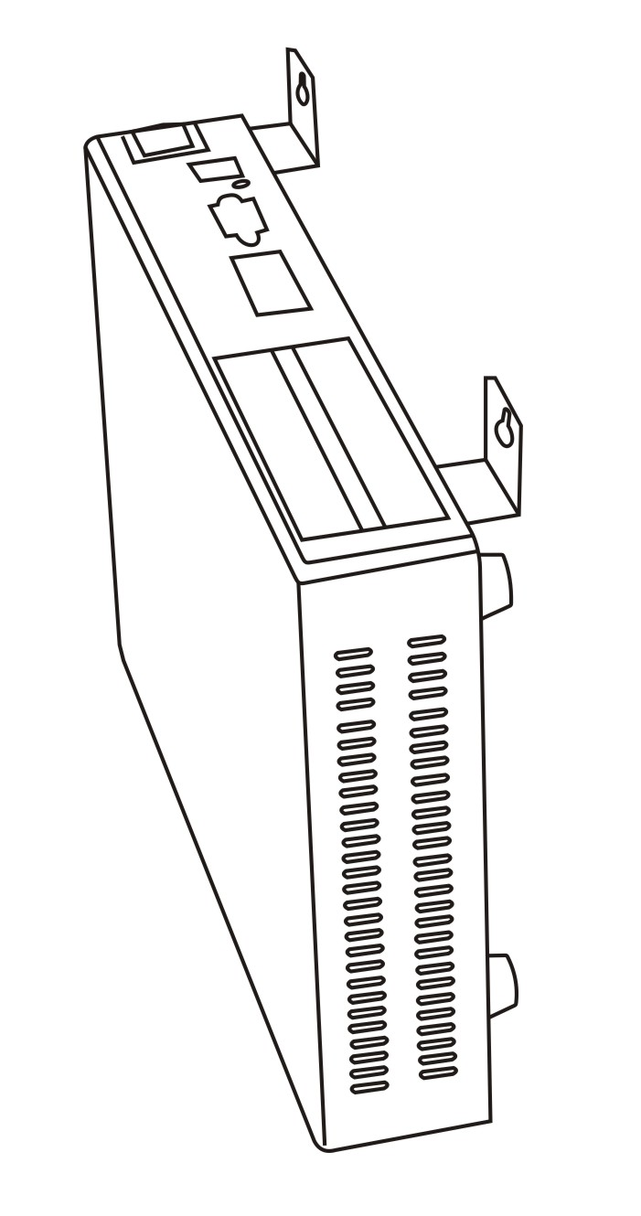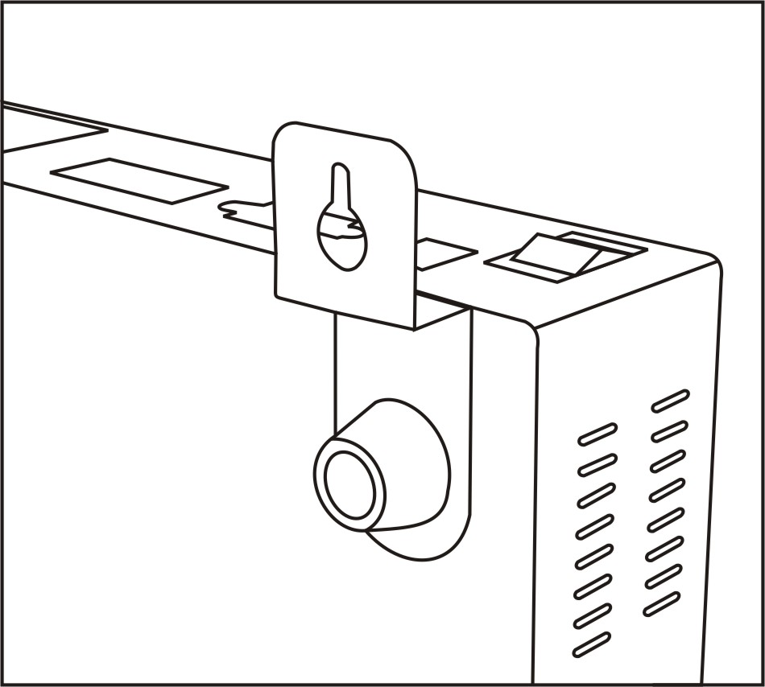


Program System Requirement
- Windows7/Vista/XP/2000
- Pentium 400MHZ CPU
- 256MB RAM
- 1GB HDD
- Network RJ45 port
- Audio output (Play & Monitor)

Connection

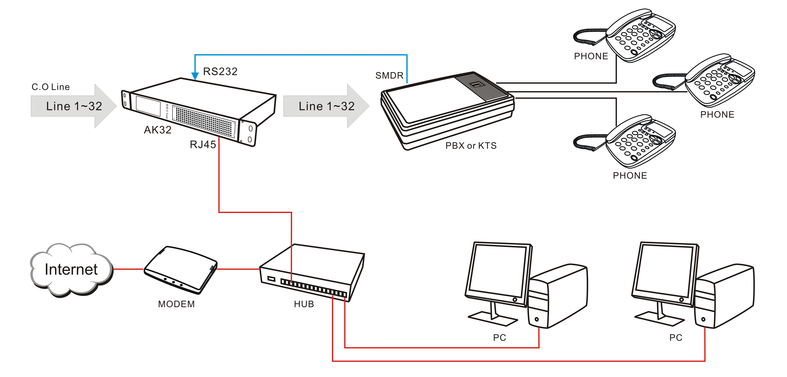

PC Program

PC Program introduction
Menu
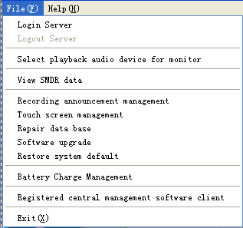

Login Recording system server
Connect with recording device through network
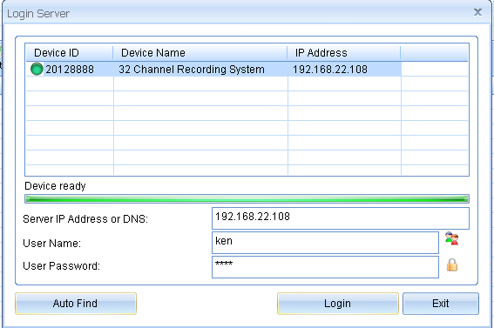
Auto search AK32 in local area network

Auto search AK32 in local area network while login

The IP address of selected the device will be saved. It will be display automatically in next login.
User Name: admin (default)
Password: 1111 (default)
- AK32 located in same LAN, you can log in with complete LAN IP address, user name and password.
- AK32 located in remote site, you can log in remotely with complete IP address or Domain name, user name and password.
For remote log in, you have to configure the IP sharing prior to AK32 site.
Bundle IP sharing port 6066
From followed example, the IP sharing can be configured as a virtual server so that remote users accessing WEB service via public IP address can be automatically redirect to local AK32 (192.168.0.103) in the LAN.

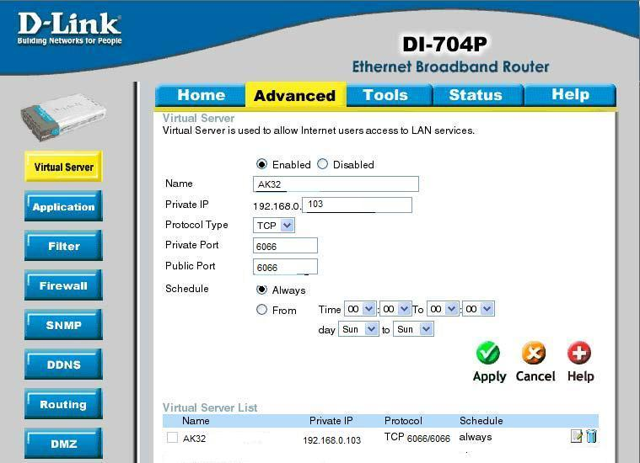

WAN IP address
- Static IP address. The IP address is fixed, will not be changed.
- Dynamic IP address: Internet user is assigned a new IP address by ISP each time logon. For remote accessing to AK32, user has to create a domain name for WAN connection.
To figure out local WAN IP address, user may visit some professional website to verify i.e.http://www.myip.cn/

Log out recording server
Log out for disconnection with recording server.

SMDR Data
You can enable/disable SMDR configuration.
Enable SMDR (Station Message Detail Recording), AK32 will receive data from PABX and pop up details on client program. You may adjust the exact data of the form.

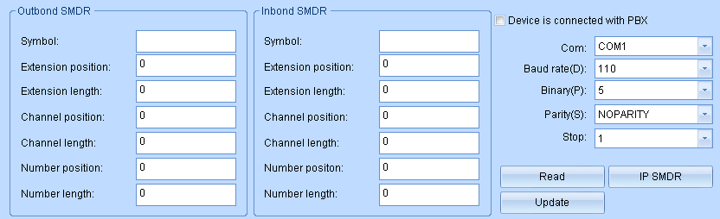

SMDR Configuration example:

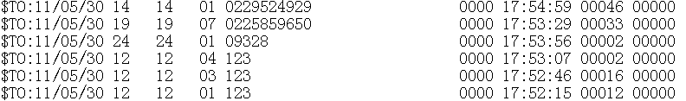

It shows extension number is 14, Channel is 01
You can count extension number position starts from the 14th digital, length is 2. Input the data to corresponded space.
The same methods, it shows channel position starts from the 24th digital, length is 2. Input the data to corresponded space.
AK32 supports Caller ID, telephone number information from SMDR will be ignored. .

Recording Announcement Management
You can upload recording announcement to AK32, it will be broadcasted to both parties while the call is established.

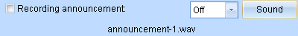

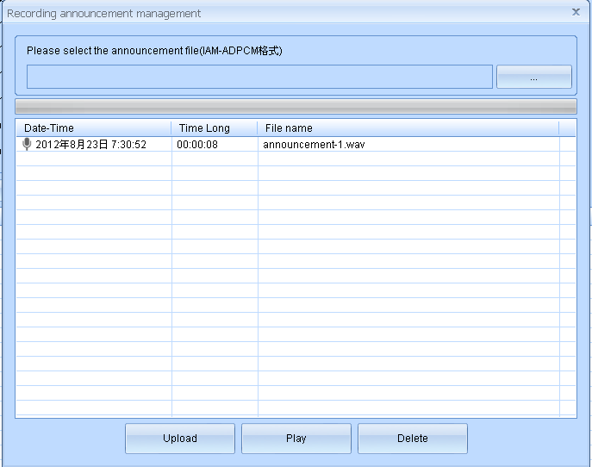
Remark: Recording announcement file should be longer than 30s. Format is IMA-ADPCM.
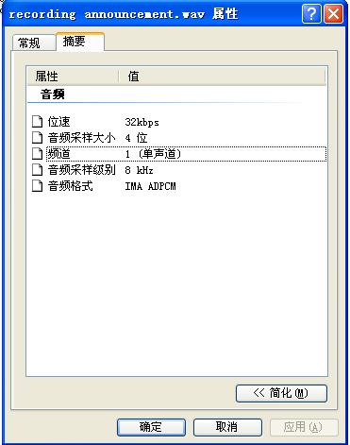

Repair database
AK32 uses SQLITE database, it saves files to \\Hard Disk\\SQLite\\2012\\201207\\CDR20120730.db daily. You can repair database by these files in case the channel’s power off or records disappeared.
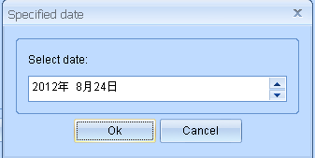

Software upgrade

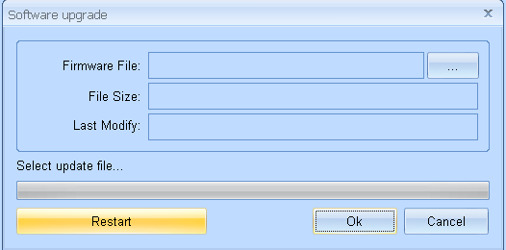

You can upload specified file to AK32 for system upgrade. System restart is required after upgrade completed. Avoid to power off and keep channels idle during upgrade processing. .

Restore system default
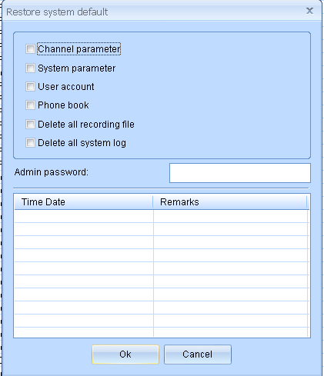.
Caution: Default setting requires administrator login to carry out the task. Administrator needs to re-enter the password to avoid abuse. Each operation is unable to be recovered and system log is unable to be removed.

- Tool Bar
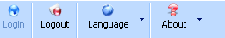

- Current operation

- Function column
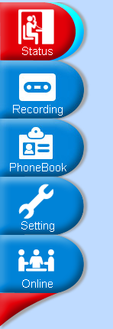

- AK32 ROM and CPU capacity indicator with date time
- HDD used capacity percentage.
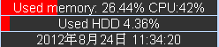

Card 1, 4 Installed properly
Card 2, 3 Error or not installed

Status Monitor

Start Monitor
Select a Channel to start monitoring conversation while the user account is authorized.

Stop Monitor
Terminate the monitoring.
Refresh
Refresh current status to PC
Display:
Program will display time, channel status, recording file, etc. User can hide some of them.
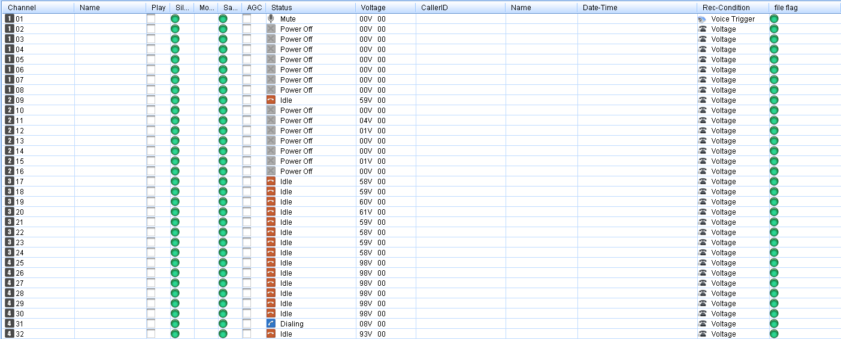

Channel No.01-32. Black label is for Card No. 1-4.
Card 1: Channel 01-08
Card 2: Channel 09-16
Card 3: Channel 17-24
Card 4: Channel 25-32

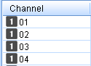

Recording announcement enabled indicator.


Mute enabled indicator. Enabled/Disabled by specific hot key
Green: Disable
Red: Enable
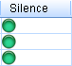

Monitor indicator. Only one channel can be monitored by a PC
Headset symbol: Being monitored.
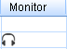

Save or not save indicator.
AK32 will not save the calls for following situations
a. Hot-t key recording. The call is unable to be saved until the specified hot-key is pressed
b.Polarity reversal recording. The call is unable to be saved until polarity reversal signal received.
C. Not record phone and extension number. Be out of recording time section.

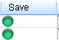

AGC indicator
AGC: Automatic Gain Control
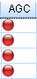
Channel Status
Indicate channel status. Include: idle, power off, dialing, etc
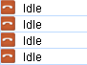

Current channel voltage
No landline in: 1-3 V Power off
Idle: >30V
Dialing: 5-24V
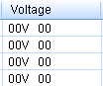

Create recording file establishing indicator
Indicate whether AK32 is recording calls properly. If the HDD is disconnected or unformatted, the indicator will not appear.
Suggest: Record the calls 1min after AK32 power on.
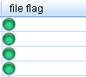

Recording

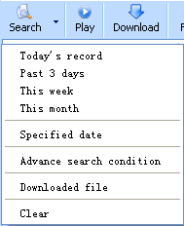
There are several time spans for quick search. If the records are searched before, the program will compare with database with last search.
- Databases are different, the program will synchronize with AK32 again.
- Databases are the same, the program will look-up local synchronized database.

Open local PC download path, list the downloaded files.

Select single or multi recording files to playback. Recording files will be downloaded to local PC simultaneously for next playback.


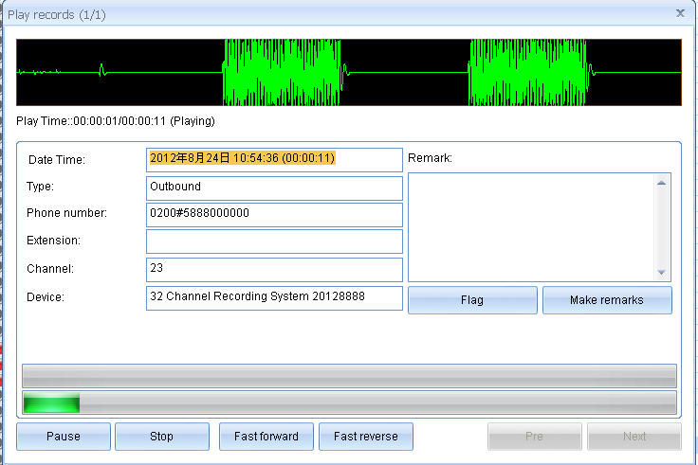
Sound

Download AK32 recording files to local PC. Downloaded file will not be downloaded twice.
Suggest: a. Carry out this task while system is idle.
b. Do not change download directory to avoid duplicated download.


Add remarks to recording files


Important recording files mark. The flagged file will not be deleted directly by mistake operation unless restore system to default.


Delete the recording file from AK32, 2 options:
      - Delete the audio file and remain the CDR
      - Delete both audio file and CDR
The operation will be listed in system log



Export CDR to Excel


Send selected recording file to specified email address. Please note the file size.



Statistics recording files by day/week/month, including inbound/ outbound/ missed calls.


Call types are distinguished with different color.

Statistics by day, listed with time section
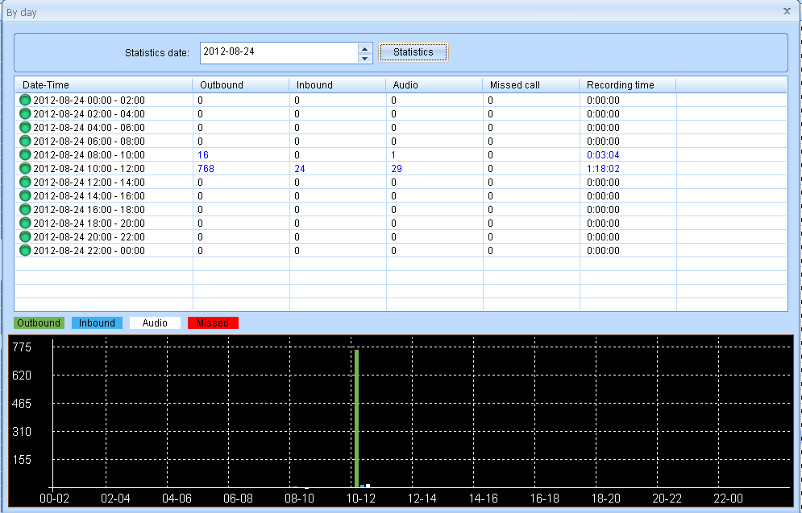

Statistics by week, listed with days
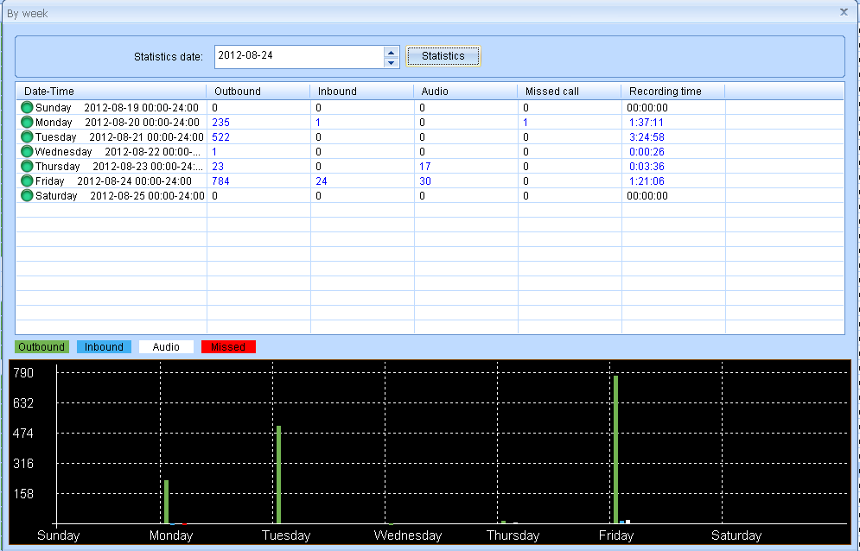

B Statistics by month, listed with dates
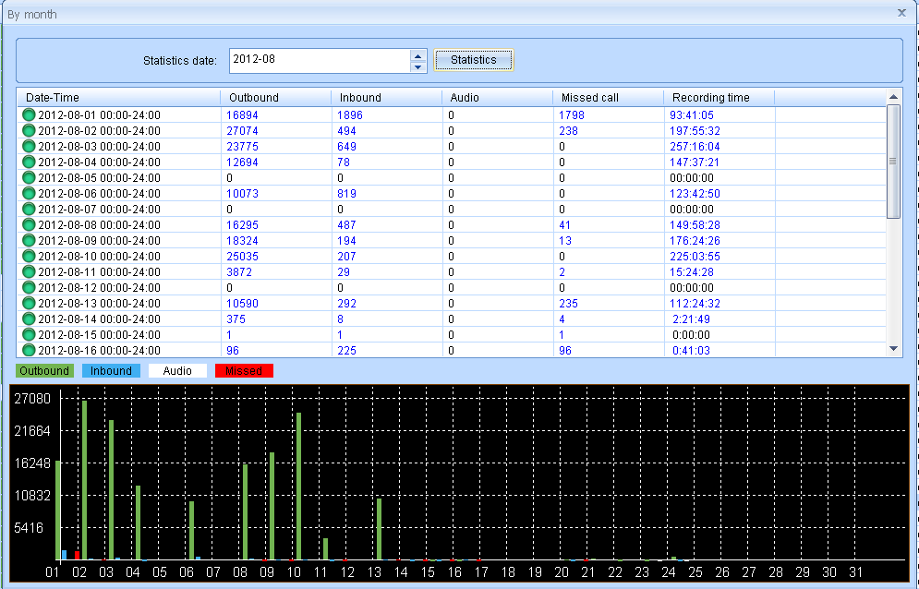

Online user can set auto backup in program. The recording files and CDR in AK32 will be downloaded to local PC on specific time for backup.


Auto backup is carried out by day/week/month from AK32 or not backup.
By day: Automatic backup daily on specific time
By week: Automatic backup weekly on specific day (Sun-Sat)
By month: Automatic backup monthly on specific date.
Not backup: Disable the auto backup function.
Start and stop time for daily backup.
Recommend: off-work time or system idle to reduce AK32 system and network occupation..
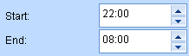

Start date: User can setup a date to start backup, normally it is the system initial date. 最
Last date: System will display previous backup date
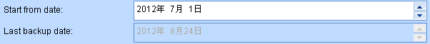

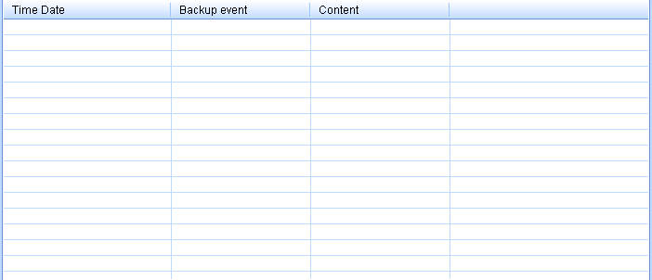

Program will display backup events include total number of records and date, etc
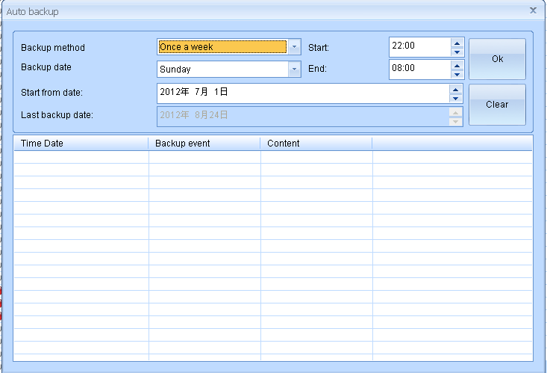
User can clear previous backup condition. System will start next backup from new specific date and downloaded file will be skipped.
Do not change backup directory to avoid duplicated files.
Main Function
- Terminate delete task. You can press this key to stop delete during processing
- Terminate Flag task
- Terminate downloading
- Terminate playing records



Phonebook
It includes Extension setting, Phonebook, Exception extension numbers and exception phone numbers.
Extension setting: The parameter works with SMDR function. The recording file will include extension number and name if the setting completed.

Phonebook: Inbound and outbound number will be saved with phonebook information.
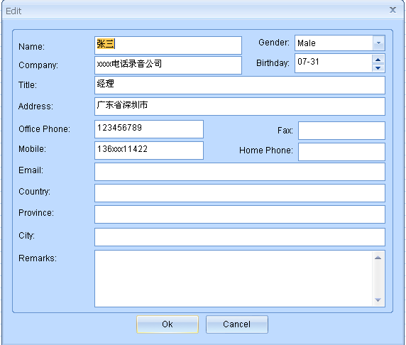

Excepted extension number: It works with SMDR. You can configure specified extension number not be recorded.
Excepted phone number: You can configure specified phone not to be recorded
Blacklist: Alert message will be generated once inbound /outbound number is in blacklist

System Setting
- The parameter is effective to entire system instead of single channel.
- It is the pause time from first digit dialing to start recording. If the value is 0, the call will be recorded entirely from pick up.

- The parameter setting is to avoid misdialing recording.
Recommend: 5s

It limits recording time to avoid large size audio file.

- User can set interval time between two DTMF digits. If the interval time is more than 7s, the latter DTMF digit will not be saved and shown in program. If the interval time is 0, all the DTMF digits will be displayed. Recommend: 7s

It is the interval time between ring tones. If the interval time is more that 7 s, the call will be determined as a missed call. Recommend: >5s

This parameter for inbound call DTMF receiving only. .

The recording file will be saved as followed format
- wav Normal audio file to be played by any PC.
- avl Encrypted audio file to be played by specified PC program
- xtr Encrypted audio file to be played by specified PC program.

- Enable /Disable to save missed call.

- Enable/disable to save non-record number of outbound call.

- Enable/Disable to save DTMF during incoming call. Yes to save all including extension number dialing from inbound call.

- The parameter works with parameter 11. You can split the recording file to save in HDD
Recommend: Yes

- Enable/Disable to save tmp file. Beside recording file, system will generate a tmp file with CDR information for each call. Recommend to enable this function, it will be useful for system repairing.

- User can set-up current AK32 system time.

- a. Synchronize with admin’s PC, admin login required.
b. Synchronize with FSK Caller ID
c. No synchronization

Command for start or stop manual recording by DTMF hotkey

Command for hide DTMF digital particular for credit card number and the length of it. The numbers will be replaced by ***
For example, (18)=556 (19)=10. As long as system receives 556 during the calls, it will show 10times * in the program instead of private card information.
Command for Start/Stop mute recording manually.
Start: Red light
Stop: Green light.
Recommend: Set up particular DTMF digit to avoid mis-dialing.

Filter ABCD in DTMF Caller ID.

- Basis of Caller ID comparison with phone book

- Use buffer to reduce times of HDD write.
Recommend: Yes

- Basis of inbound call determination. It is able to identify the call signals from the noise
Recommend:3

- Power off: Without landline in channel. The parameter determines if save the status in system log.
Recommend: No.

Identify busy tone ON/OFF time (ms) on the landline. Mostly ON/OFF = 500/500in China and 250/250 in Taiwan. User may record busy tone on site and analyze it by Cool Edit. 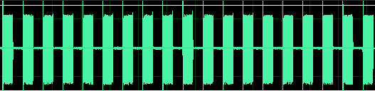

- Identify busy tone in auto-answer mode. Besides busy tone ON/OFF time, user has to set up busy tone volume level to distinguish sound and soundless. Therefore, misjudgment during talking would be avoided. .
- Enable/Disable auto-answer on Saturday. Enable it for auto-answer all day long on Saturday and auto-answer time sections setting will be ignored.

- Enable/Disable auto-answer on Sunday. Enable it for auto-answer all day long on Sunday and auto-answer time sections setting will be ignored.
Non-Record numbers comparison.
a. Fuzzy: Call will not be recorded if the non-records numbers is included in whole number string.
Example: 200 is Non-record number, the calling number 92001 would NOT be recorded.
b. Precise: Call will not be recorded if the calling number is exactly match with original setting.
Example: 200 is Non-record number, the calling number 92001 would BE recorded.

Configure it carefully to save the necessary call record.

Channel Parameter
- You can create a name for each channel. The name will be along with recording file, it also will be shown on monitor page.
For example ”Accounting 0755-27746xxx”

- This parameter works with PABXSMDR. AK32 channel must be corresponded with PABX channel.

- Normally we use Voltage for most analog lines.
- Key recording: Manually recording by press hot key.
Refer system setting 16, 17

- Voice trigger: Start recording while sound reaches specified level. Otherwise, the call will not be recorded. Particular parameter for microphone & interphone recording. DTMF signal will be not recorded.
- Continuous Recording: Non-stop recording. Usually for microphone and interphone recording. DTMF during the call will not be recorded.
- Polarity Reversal: Start recording while polarity reversal signal received.
Remark: You need to subscribe polarity reversal signal service from local telecom service provider.
The greater level comes with greater volume of recording file and noise.

The greater lever comes with greater volume of playing volume and noise.

- Enable/Disable recording announcement. Recording announcement will be broadcasted to both side of a call and it will be saved in recording file.
- 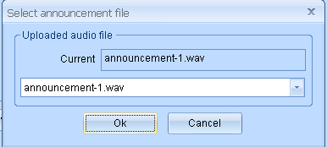 Upload an existed announcement file to AK32.

- Enable to play recording reminder to both side during a call. .
Reminder file ” rec-remind.wav” is less than 2second and unable to modify.

This is voltage level to verify if the channel is plug with landline.
Recommend: 3V

- This is minimum voltage setting to verify if telephone is hook on.
Recommend: 25V

- AGC: Automatic Generation Control. To average the sound of both parties in a call.
Recommend: Disable this function in voice trigger recording.

- Time elapse setting for specified voltage of ON/OFF hook.

- Time setting for specific voltage to verify ringtone ON and OFF.

Definition of landline plug in.
Power on: <value
Power off: >value
- Definition of polarity reversal lasting time.

- Read only.
- 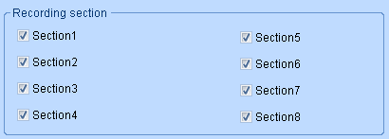 一Generally AK32 record the phone call in all section. Time setting see recording time section.

- 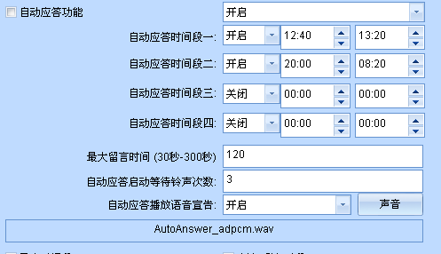

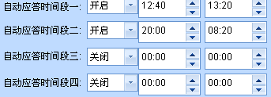
Channel setting for auto-answer.
Time Section: 24Hours range
Voice message: 30-300s from start prompts..
Auto- answer ring: Ring times before auto-answer
Auto-answer announcement: Load specified auto-answer announcement to device. Recommend file time: Less than 1 min

Voice Trigger parameter

User needs to configure sound level and sensitivity when the channel is set voice trigger recording.
Sound lasting time (ms): The specific level sound lasts time for start recording. The lower value comes with higher sensitivity.
Silent lasting time (ms): The silent sound lasts time for stop recording. Configure a large value to avoid multiple recording files caused by silent during conversation.
Volume level: Voice trigger sound lever. The lower value causes easier trigged.

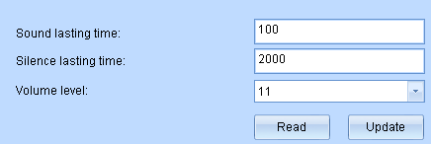

Network Setting

User can configure network setting same as PC.
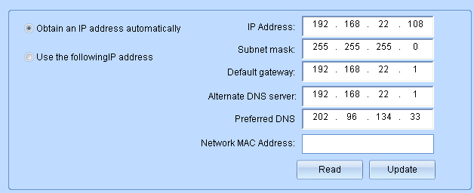

HDD Parameter and system log
HDD reserved space: It is for HDD read/writer buffer.
Recommend: 10%
Loop recording: Enable this function, the latest record will cover the initial recorder when HDD is full
Disable it, AK32 will stop recording when HDD is full until it is exchanged.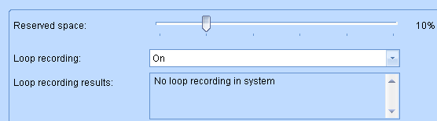

It indicates HDD current space, total operation time and remaining time. Remaining time is calculated by average parameter of used HDD. Exact remaining time is based on actual conditions.

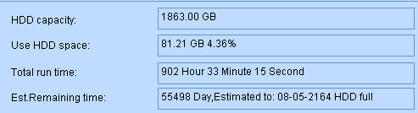
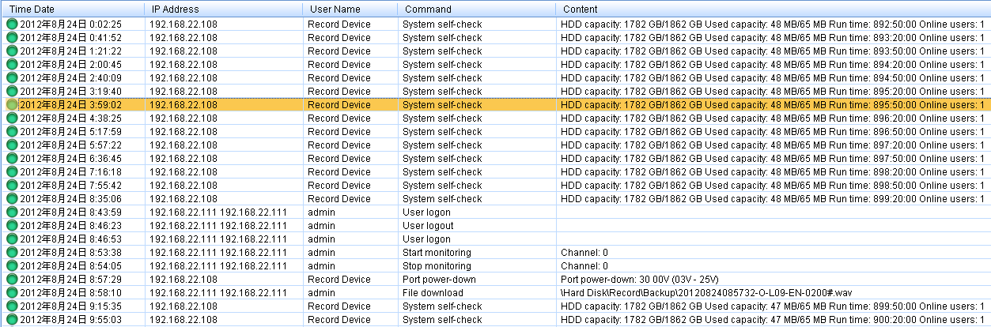

System log: The critical operation will be recorded in system log.

Recording Time Section
Flexible combined with 8 recording time sections. It is used in channel setting, special for recording storage option.
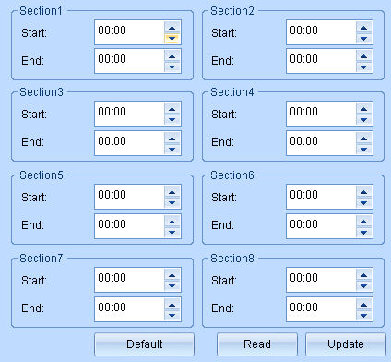

PABX SMDR
There are 2 methods to gain the SMDR data from PABX
- RS232
- TCP/IP
User needs to analyze original data of PABX channel number, extension number from followed main parameters and input them to program setting.
Outbound call
- Call symbol: The mark to distinguish the call type (Outbound/Inbound call) in character string. Most PABX show “TO “ to indicate outbound call.
- Extension position: User have to count the extension number starting position in character strings.
- Extension number length: Extension number length.
- PABX channel number position: User has to count the channel number starting position in character strings.
- Channel number length: PABX channel number length.
From followed example, user can read out outbound call information
- Call symbol: $TO
- Extension position: 14th
- Extension number length: 2.
- PABX channel position: 24th
- Channel number length: 2
Remark: AK32 is able to decode DTMF for call number itself, the phone number from SMDR will be ignored.
Outbound call:
Same as Inbound call verification.

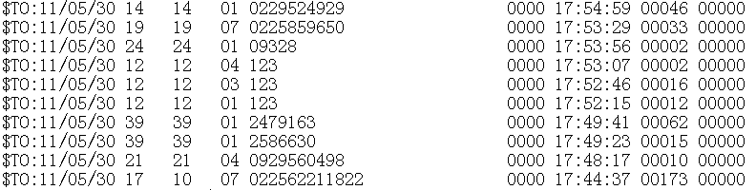

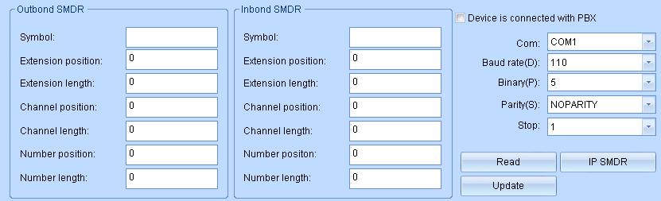

PABX SMDR Protocol
Do not check this option if there’s no SMDR connected.
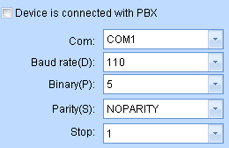
Please refer PABX user’s manual about serial communication configuration for windows HyperTerminal operation
Gain SMDR data through TCP/IP
Most PABX support TCP/IP SMDR. Please refer PABX user’s manual about SMDR output parameter.
- PABX IP address: The IP address assigned to PABX
- Connect Port: Port for PC connection (Provided by PABX)
- Output Port: Normally it is same as connection port. Otherwise, user can set separately.
- User Name: User name to login PABX.
- Password: Password to login PABX

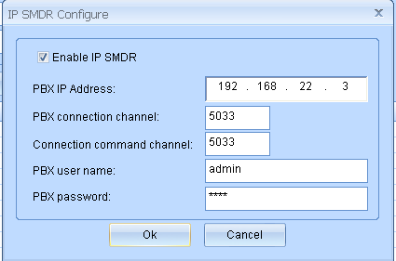
Do not check this option if there’s no IP SMDR

Inbound Call on hold. Program will create new call record while the inbound call is on hold and transferred to another extension when SMDR is received.

Outbound Call on hold. Program will create new call record while the outbound call is on hold and transferred to another extension when SMDR is received.

Identify the extension is on hold or hang up for above call record settings.

Other setting
Enable /Disable to popup call numbers and corresponded information when it exists in phonebook
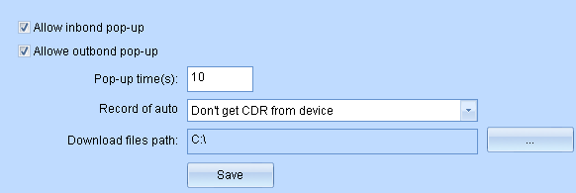
Elapse time for popup window. Always stays when the value is 0.

Enable/Disable to pop-up login window while running PC program

Enable/Disable to run program while PC restart

Enable/Disable to re-connect network automatically while it is disconnected

Enable/Disable to clear screen while network is disconnected

Enable/Disable to remind long time hook off. It caused by a. Line error b. Handset is not hang up properly.

Enable/Disable to remind power-off

Enable/Disable to remind Channel time out.

Enable/Disable to play alert on PC.

Enable/Disable to generate alert message for blacklist

Enable/Disable inbound call pop-up window

Auto Sync.: Auto synchronization method if AK32 recording file and CDR are different with program’s.
Downloaded files path: Do not change it frequently to avoid duplicated downloading and speed slowing down.

Online user



Online user: User who is log in AK32 now
Showing online time, online duration, IP address, software version and MAC address

User Management
Administrator can add new user to log in AK32
Default user: admin
Default password:1111.

Add new account
User name: Max. 16 characters
Password: Max 16 characters
Enable the authorization for

- Add/Delete user account

User can assign various authorization levels for supervisor and staff in a firm.
For example, user can check all channels for supervisor’s account and single channel only for staffs. When staff login AK32, only one line status is visible in his client program.

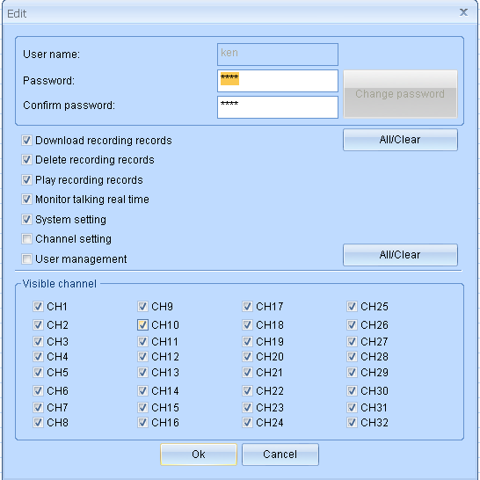

Touch screen
There are 8 function divisions on touch screen, including CDR, Search, Channel Monitor, Status, Settings, Network, Tools and System. .
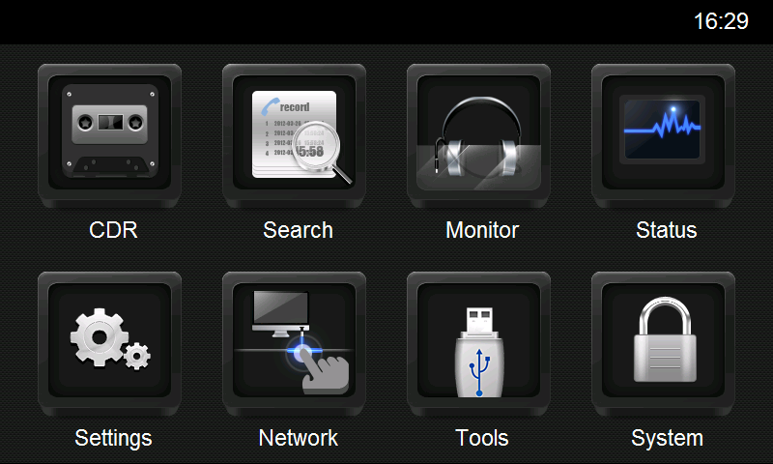

CDR (Call Detail Recording)

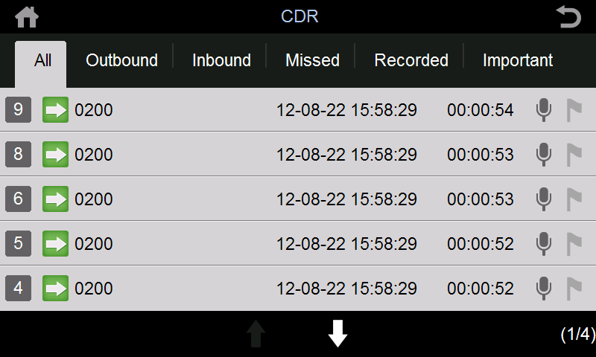
-  Back
-  Back to main menu
-  Recording of Channel
-  Outbound call
-  Inbound call
-  Missed call
- Telephone number 0200
- Start time and date
- Recording elapse HH:MM:SS
-  Audio file
-  Flag symbol for important call. Red: flagged Grey: None
- Page Down & Page Up. (Effective on bright one)
- 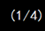 Current page/Total page

Search CDR
Search the records by various conditions.
Recommend: Database is saved daily. Search speed depends on time span.
AK32 supports SQL searching as well.

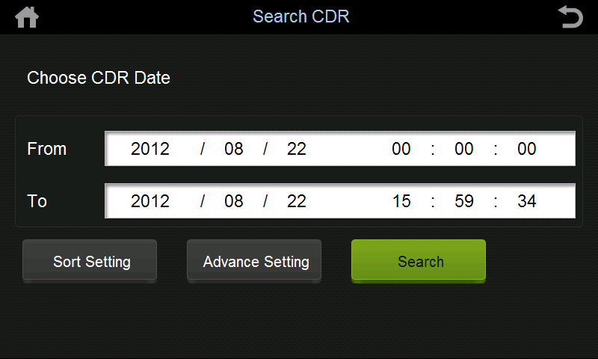

Channel Monitor
You can check one card (8 channels) in one page. It shows Channel number, status telephone number, recording time and status.
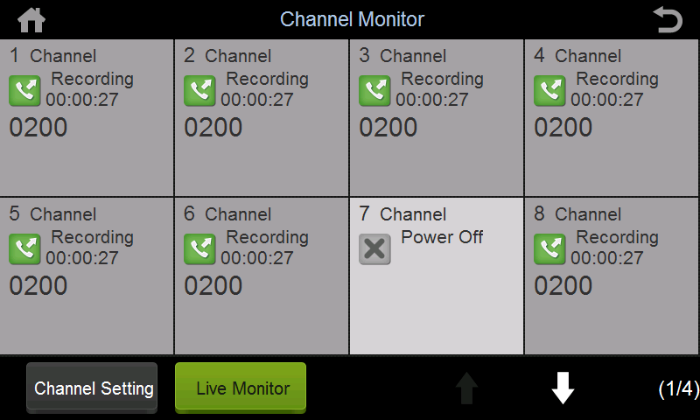

Channel Status
It shows instant status of 32 Channels. Symbol only.
-  Dialing
-  Idle
-  Inbound call
-  Outbound call
-  Power off (Landline disconnected)
-  Ringing
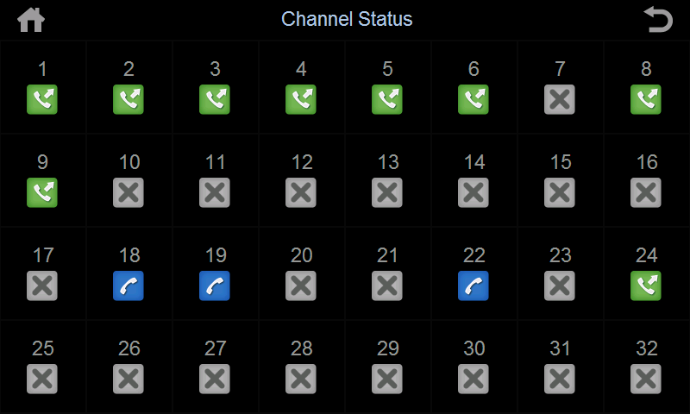

Setting
Touch screen supports Channel Setting, System Setting, Screen Lock Setting
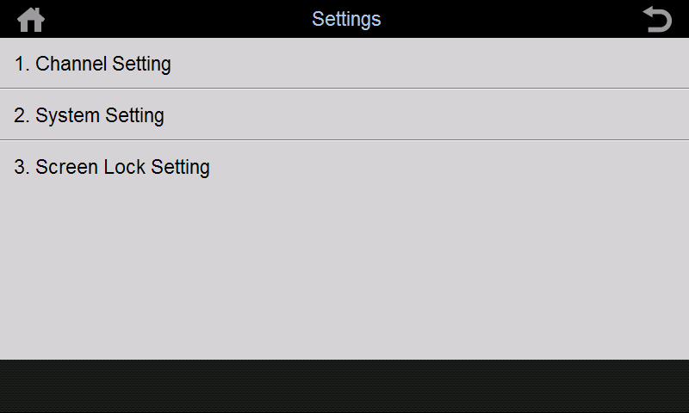

Channel Setting
Set up Channel 01-32 parameter (See PC program setting)

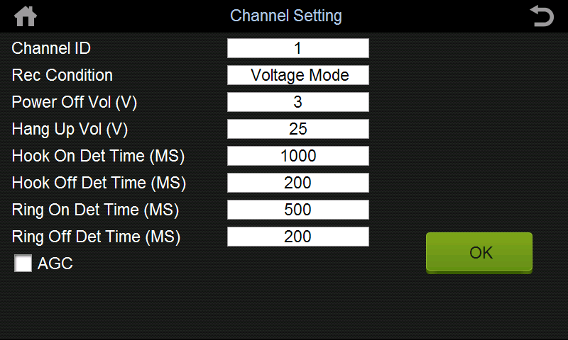

System Setting
Touch screen supports date and language setting only.

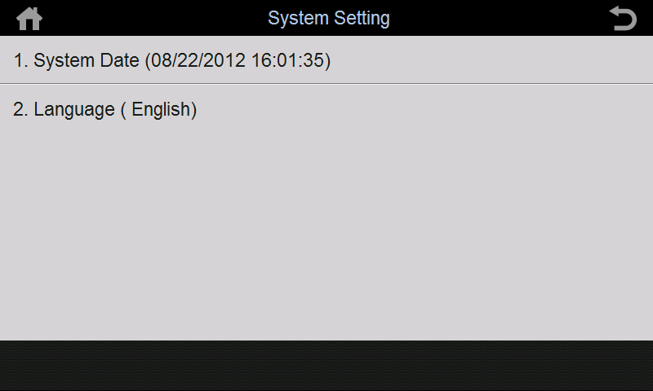

Scree Lock Setting
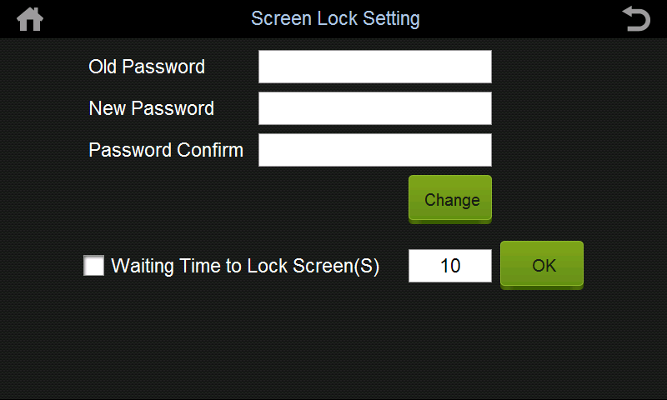

Network Configuration
Configure AK 32 network detail. Restart AK32 after configuration.
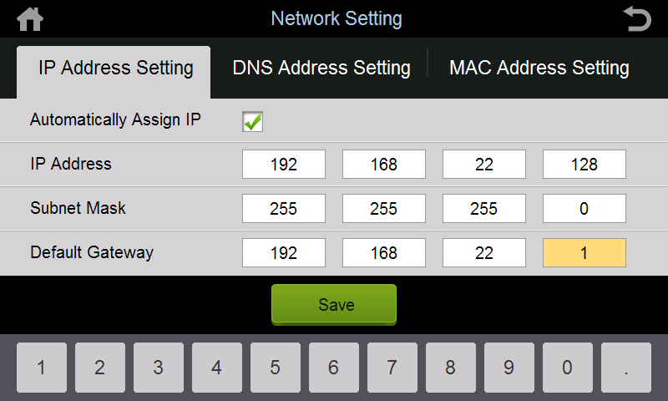

Tools
Plug in USB storage device to upgrade firmware (upgrade file enclosed) or backup.
Restart AK32 after upgrade file transfer completed.
FW_UPDATE directory (phoneTouch.exe PhoneRec.exe)

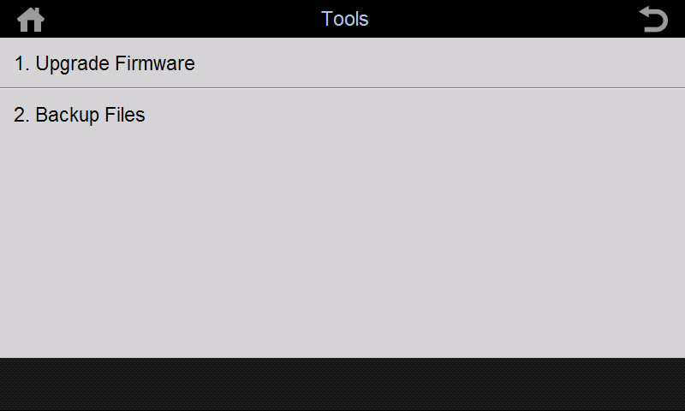

System
Display system default information and program version.

